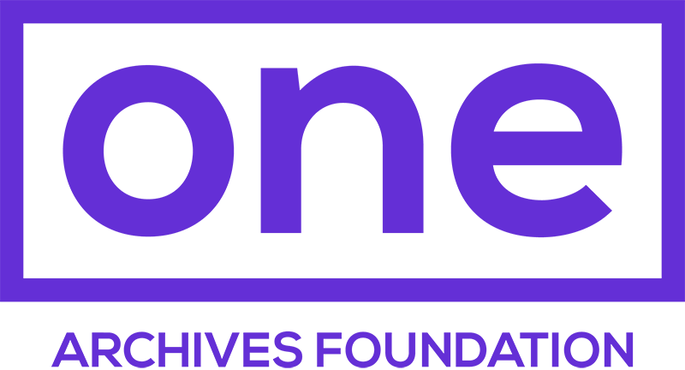

ONE BUSINESS PARTNERS  
  
Show your valid membership card and enjoy discounts at the businesses below.

|  |  |
| --- | --- |
| **Arcana: Books on the Arts**  8675 Washington Blvd  Culver City, CA 90232  **10% Discount** | **Otherwild**  1768 N Vermont Ave  Los Angeles, CA 90027  **15% Discount** |
| **Ooga Booga**  943 N Broadway #203  Los Angeles, CA 90012  **10% Discount** | **Bitten Peach**  www.bittenpeach.com  **10% Discount on First Private Chef  or Kitchen Coach Session** |
| **Skylight Books**  1818 N Vermont Ave  Los Angeles, CA 90027  **10% Discount** | **Masa of Echo Park Bakery & Cafe**  1800 Sunset Blvd  Los Angeles, CA 90026  **15% Discount all Dine-In Guests**  (Parties of 6 or fewer) |
| **ONE Gallery,**  **West Hollywood**  626 N Robertson Blvd,  Los Angeles, CA 90069  **10% Discount** | *Partner list as of December 2018.* |